**Hall Booking Task Post Man ScreenShot**

**PostMan Documentation**

**<https://documenter.getpostman.com/view/36384047/2sA3kUFgcD>**

**Get:Call**

<http://localhost:4000/api/hallbooking/getDetails>

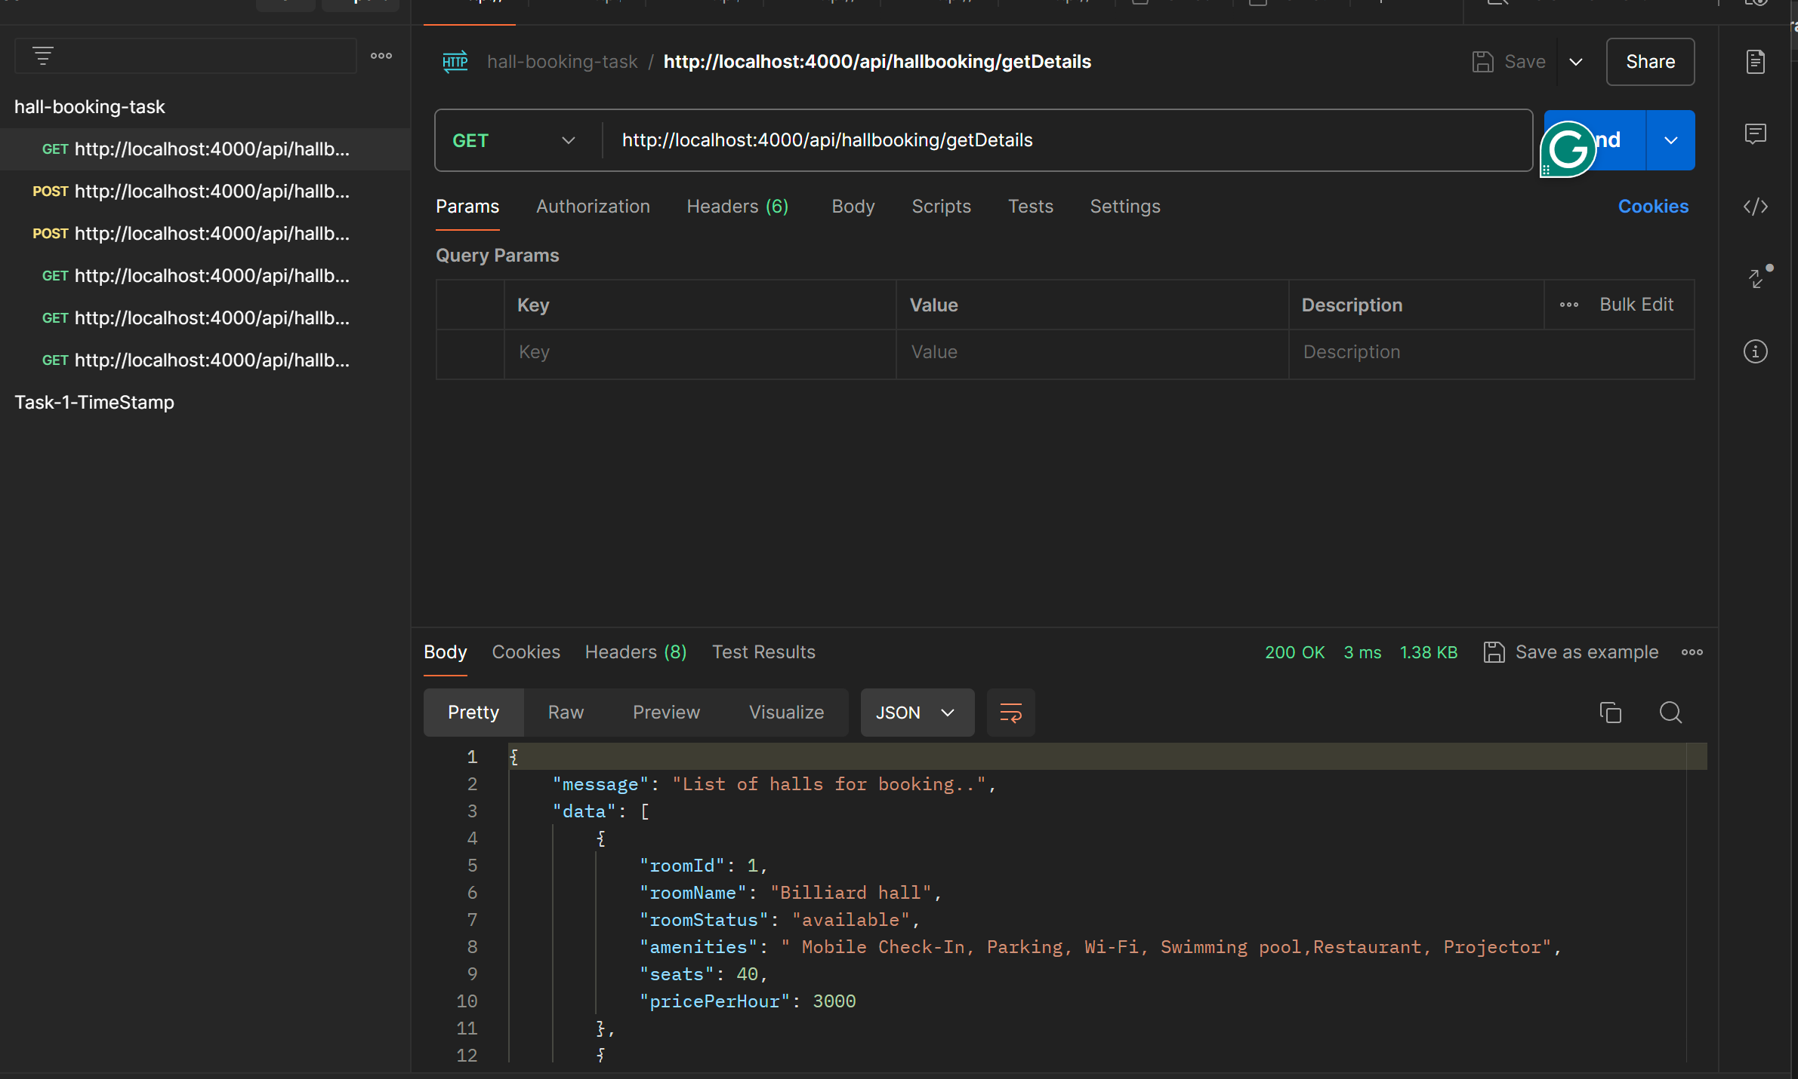

**Post:Call**

<http://localhost:4000/api/hallbooking/newRoom>

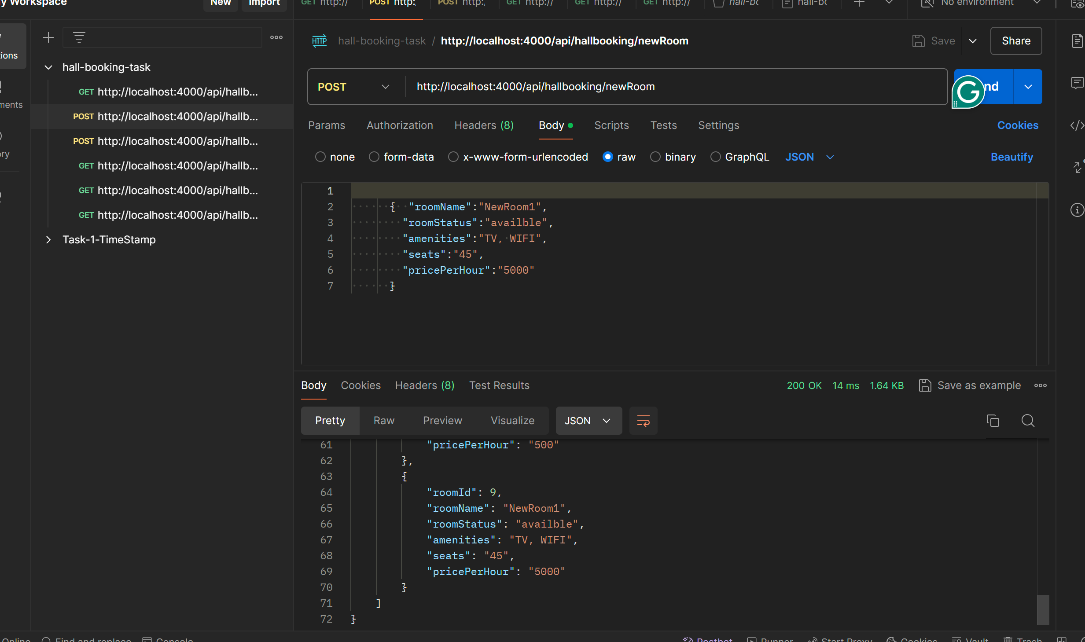

**Post:Call**

<http://localhost:4000/api/hallbooking/newbooking>

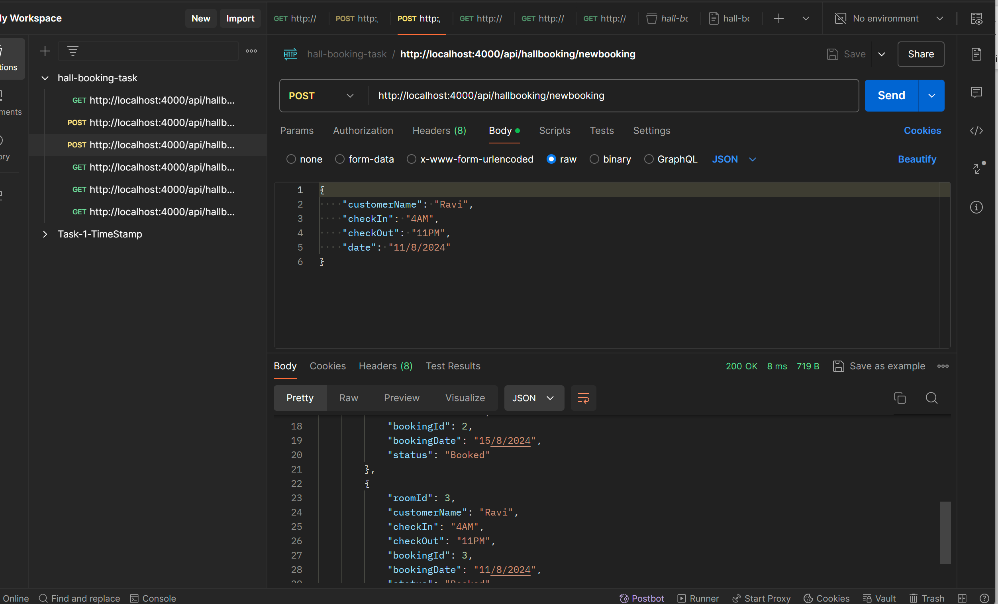

**Get:Call**

<http://localhost:4000/api/hallbooking/bookedRoomDetails>

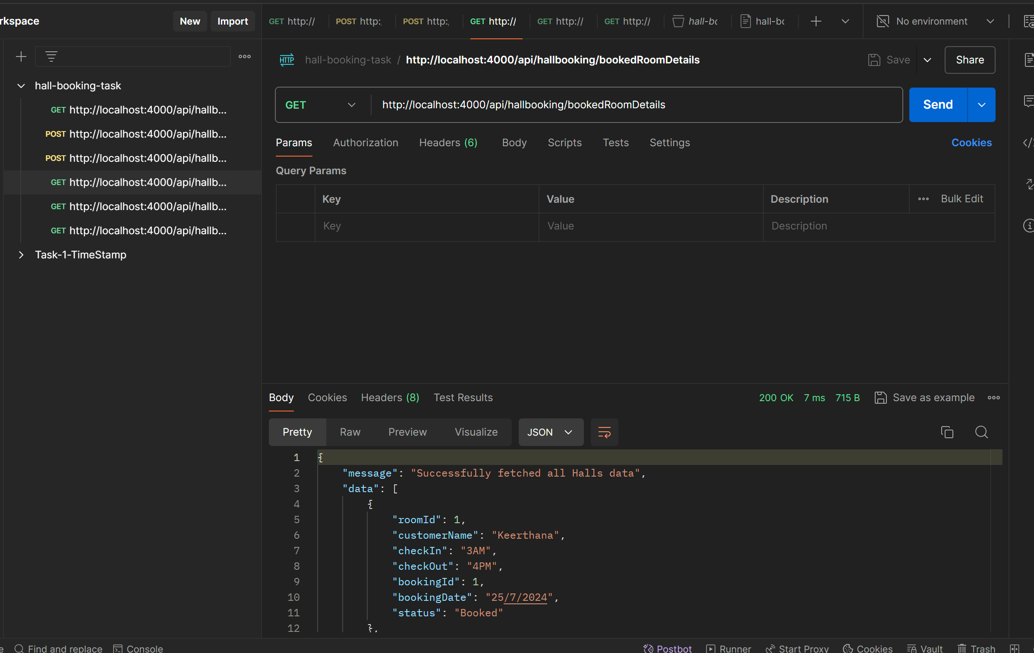

**Get:Call**

<http://localhost:4000/api/hallbooking/customerBookedDetails>

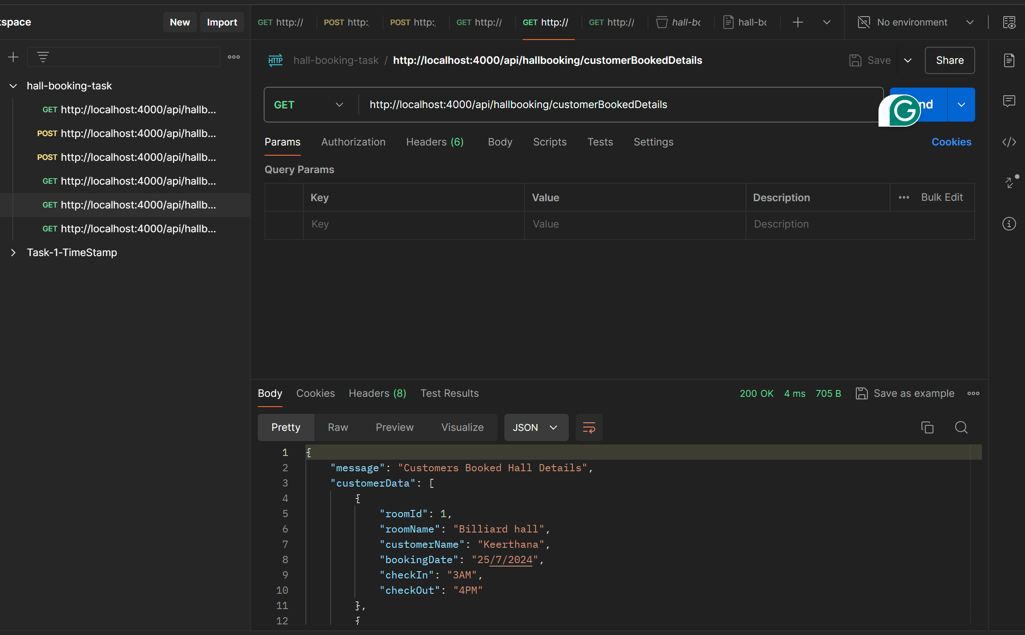

**Get:Call**

<http://localhost:4000/api/hallbooking/cusbookcount>

